MPC-MAP Assignment No. 1 - Report

Author: Tomáš Špelda

Date: 27. 3. 2026

Task 1

Task 2

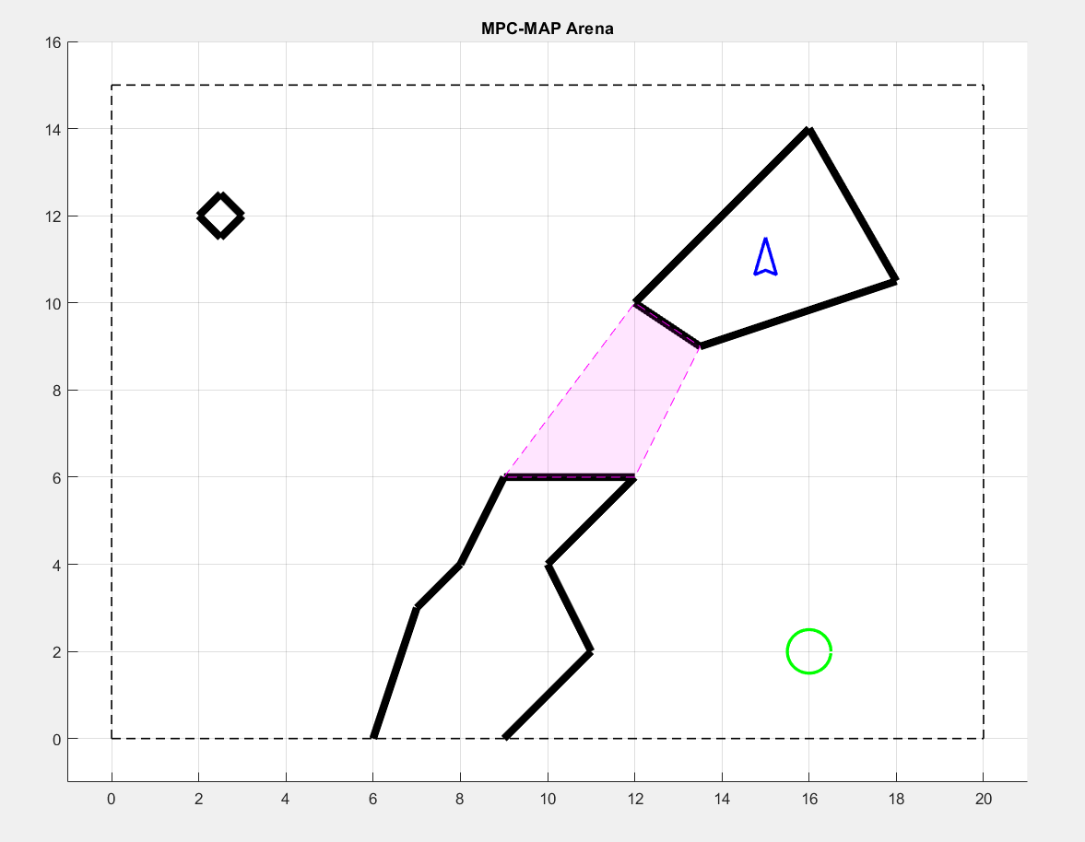
Figure 1 Used map

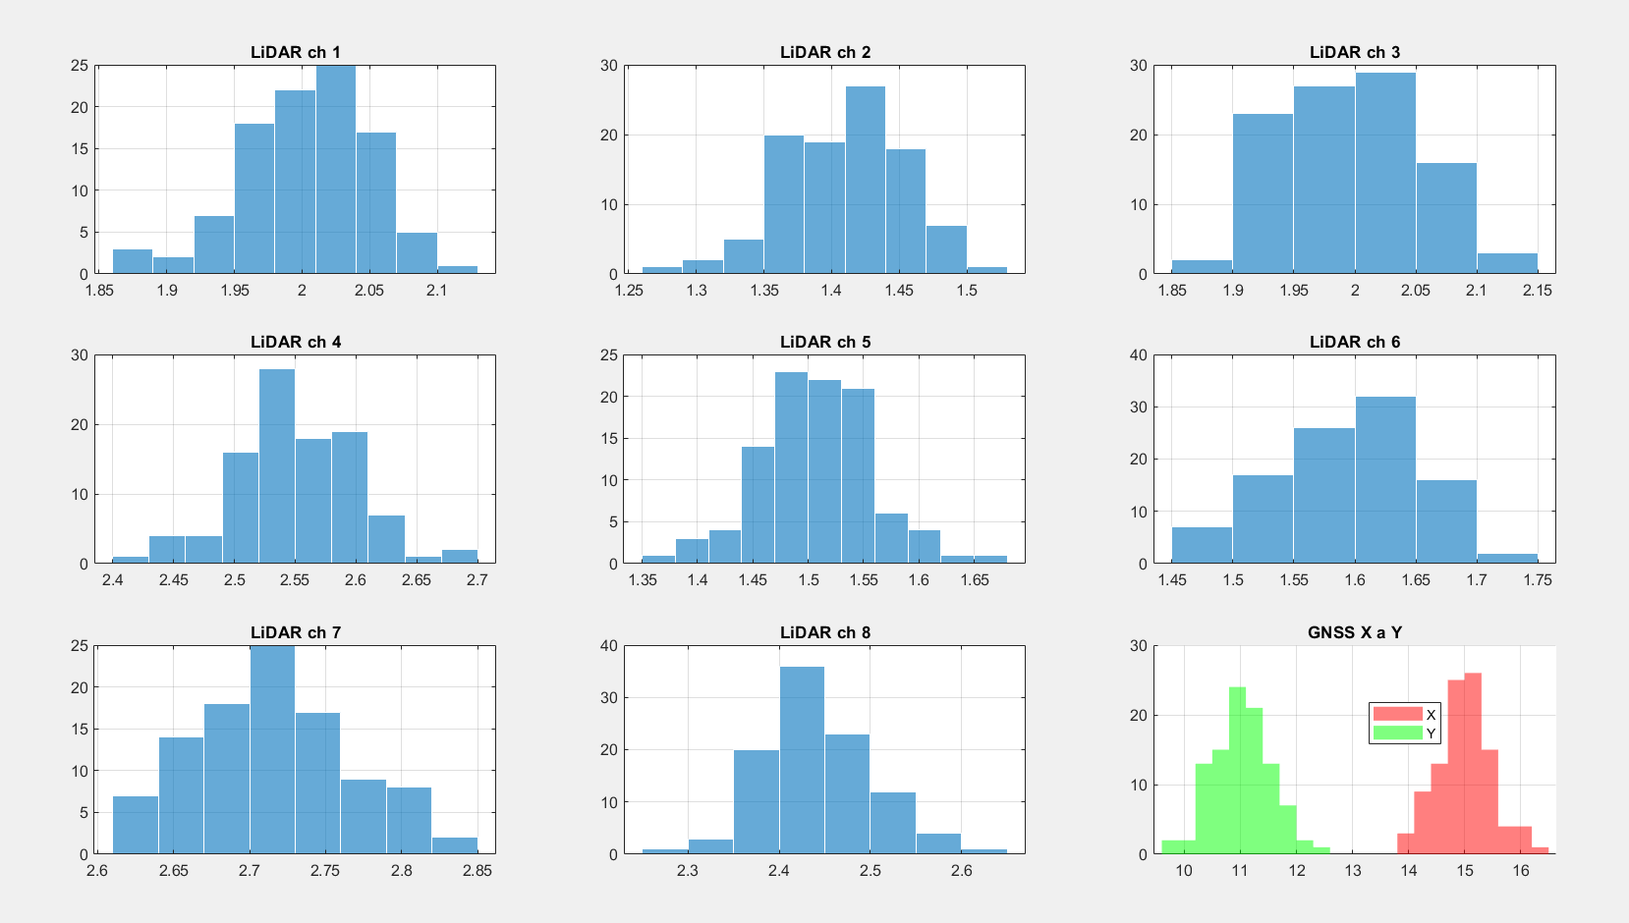
Figure 2 Histograms

The standard deviation is not consistent across individual LiDAR channels due to different distances from the walls.

Task 3
The matrices have proper size and the values on the main diagonal are equal to sigma^2, see screenshot:

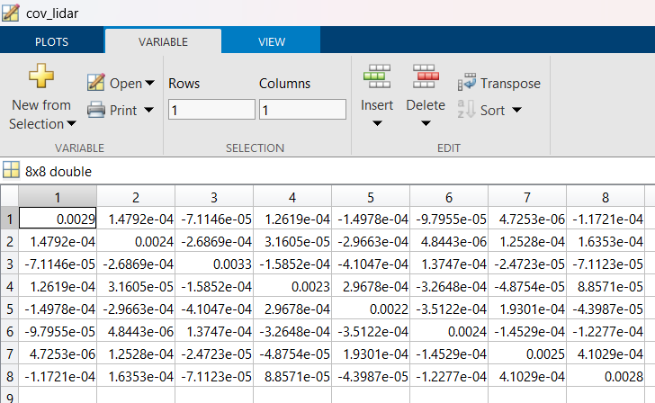 | 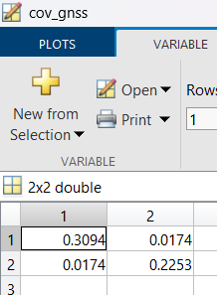

Task 4
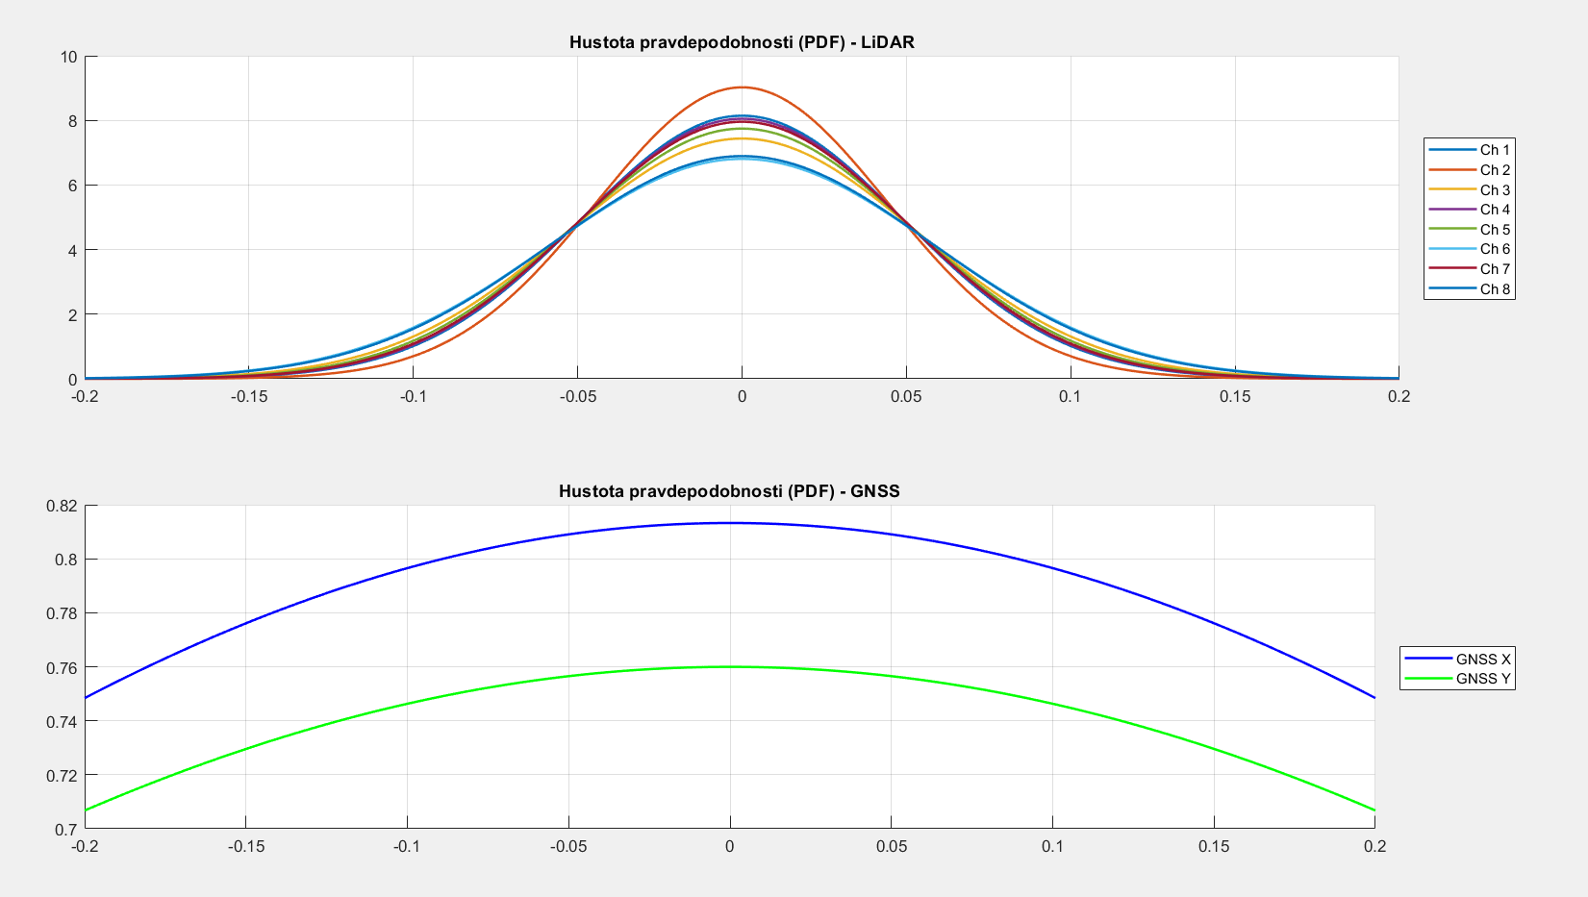

Task 5
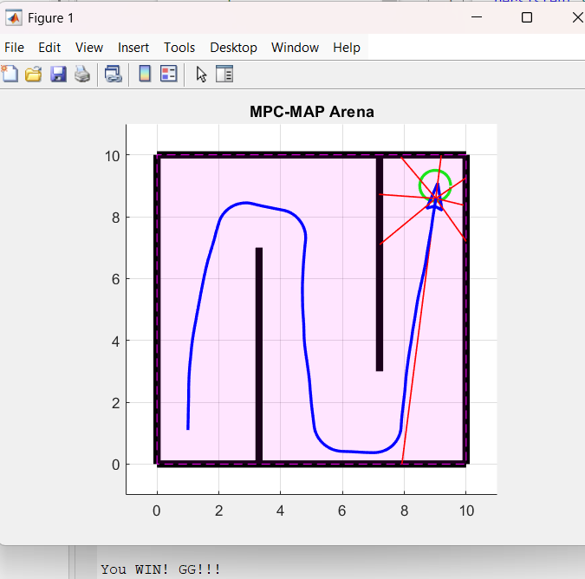
The uncertainty exist in the motion (grip, slip, radius of the wheel, distance of the wheels)

Github repository: https://github.com/Lagiontom/MPC-MAP

